Demographic Sentencing Disparities Baseline Switch
July 28, 2023
This document attempts to replicate the Commission’s “refined model” for estimating demographic disparities in sentencing. For more information about the model and for the reference regressions, see “Demographic Disparities Baseline Switch Reference Docs.” For a write-up of findings, see the latest version of the Data Learnings Memo.
This version of our analysis incorporates the script that we received from Ryan Cotter at the Commission. It also adds a filter for the “Sources” variable (per Ryan’s email over the summer).

White Male Baseline Regressions

Post-Protect
 | Estimate | Standard Error | t value | Pr(>|t|)
(Intercept) | 0.554 | 0.021 | 26.633 | 0.0000 | ***
logmin | 0.692 | 0.003 | 276.736 | 0.0000 | ***
drugtraffTRUE | 0.199 | 0.017 | 12.006 | 0.0000 | ***
sexual2TRUE | 0.166 | 0.065 | 2.572 | 0.0101 | *
pornTRUE | 0.195 | 0.051 | 3.805 | 0.0001 | ***
immigrationTRUE | 0.168 | 0.021 | 7.836 | 0.0000 | ***
othtypeTRUE | -0.429 | 0.030 | -14.197 | 0.0000 | ***
whitecollTRUE | -0.366 | 0.019 | -18.838 | 0.0000 | ***
upwardTRUE | 1.064 | 0.056 | 18.981 | 0.0000 | ***
downdepTRUE | -0.905 | 0.016 | -54.888 | 0.0000 | ***
subasstTRUE | -1.177 | 0.016 | -74.909 | 0.0000 | ***
mandmin2 | 0.105 | 0.018 | 5.840 | 0.0000 | ***
NEWCNVTN | 0.257 | 0.025 | 10.133 | 0.0000 | ***
custody | 0.750 | 0.014 | 55.521 | 0.0000 | ***
relevel(factor(racesex), ref = 8)blackfemale | -0.426 | 0.029 | -14.826 | 0.0000 | ***
relevel(factor(racesex), ref = 8)blackmale | 0.086 | 0.016 | 5.494 | 0.0000 | ***
relevel(factor(racesex), ref = 8)hispfemale | -0.283 | 0.030 | -9.586 | 0.0000 | ***
relevel(factor(racesex), ref = 8)hispmale | -0.013 | 0.017 | -0.729 | 0.4657
relevel(factor(racesex), ref = 8)otherfemale | -0.556 | 0.059 | -9.469 | 0.0000 | ***
relevel(factor(racesex), ref = 8)othermale | -0.065 | 0.031 | -2.108 | 0.0350 | *
relevel(factor(racesex), ref = 8)whitefemale | -0.285 | 0.025 | -11.471 | 0.0000 | ***
agedummyTRUE | 0.039 | 0.013 | 3.088 | 0.0020 | **
educTRUE | -0.061 | 0.014 | -4.440 | 0.0000 | ***
citizen | 0.019 | 0.016 | 1.152 | 0.2492
Signif. codes: 0 <= '***' < 0.001 < '**' < 0.01 < '*' < 0.05
Residual standard error: 1.327 on 66133 degrees of freedom
Multiple R-squared: 0.7074, Adjusted R-squared: 0.7073
F-statistic: 6951 on 66133 and 23 DF, p-value: 0.0000

Post-Booker
 | Estimate | Standard Error | t value | Pr(>|t|)
(Intercept) | 0.414 | 0.016 | 26.025 | 0.0000 | ***
logmin | 0.699 | 0.002 | 356.173 | 0.0000 | ***
drugtraffTRUE | 0.221 | 0.012 | 18.281 | 0.0000 | ***
sexual2TRUE | 0.122 | 0.044 | 2.755 | 0.0059 | **
pornTRUE | 0.448 | 0.030 | 15.174 | 0.0000 | ***
immigrationTRUE | 0.159 | 0.015 | 10.387 | 0.0000 | ***
othtypeTRUE | -0.438 | 0.022 | -19.967 | 0.0000 | ***
whitecollTRUE | -0.308 | 0.014 | -21.451 | 0.0000 | ***
upwardTRUE | 0.982 | 0.030 | 33.270 | 0.0000 | ***
downdepTRUE | -0.899 | 0.009 | -96.078 | 0.0000 | ***
subasstTRUE | -1.084 | 0.012 | -90.888 | 0.0000 | ***
mandmin2 | 0.190 | 0.012 | 15.445 | 0.0000 | ***
NEWCNVTN | 0.323 | 0.018 | 18.256 | 0.0000 | ***
custody | 0.773 | 0.010 | 77.683 | 0.0000 | ***
relevel(factor(racesex), ref = 8)blackfemale | -0.303 | 0.022 | -13.896 | 0.0000 | ***
relevel(factor(racesex), ref = 8)blackmale | 0.159 | 0.011 | 13.978 | 0.0000 | ***
relevel(factor(racesex), ref = 8)hispfemale | -0.281 | 0.021 | -13.598 | 0.0000 | ***
relevel(factor(racesex), ref = 8)hispmale | -0.001 | 0.013 | -0.100 | 0.9203
relevel(factor(racesex), ref = 8)otherfemale | -0.319 | 0.040 | -7.918 | 0.0000 | ***
relevel(factor(racesex), ref = 8)othermale | 0.039 | 0.021 | 1.816 | 0.0693 | .
relevel(factor(racesex), ref = 8)whitefemale | -0.226 | 0.018 | -12.374 | 0.0000 | ***
agedummyTRUE | 0.038 | 0.009 | 4.012 | 0.0001 | ***
educTRUE | -0.052 | 0.010 | -5.269 | 0.0000 | ***
citizen | 0.071 | 0.012 | 6.032 | 0.0000 | ***
Signif. codes: 0 <= '***' < 0.001 < '**' < 0.01 < '*' < 0.05
Residual standard error: 1.352 on 134988 degrees of freedom
Multiple R-squared: 0.6703, Adjusted R-squared: 0.6703
F-statistic: 1.193e+04 on 134988 and 23 DF, p-value: 0.0000

Post-Gall
 | Estimate | Standard Error | t value | Pr(>|t|)
(Intercept) | 0.417 | 0.013 | 31.003 | 0.0000 | ***
logmin | 0.633 | 0.001 | 422.162 | 0.0000 | ***
drugtraffTRUE | 0.176 | 0.010 | 17.576 | 0.0000 | ***
sexual2TRUE | 0.202 | 0.037 | 5.464 | 0.0000 | ***
pornTRUE | 0.599 | 0.021 | 28.299 | 0.0000 | ***
immigrationTRUE | 0.143 | 0.012 | 11.548 | 0.0000 | ***
othtypeTRUE | -0.651 | 0.018 | -36.211 | 0.0000 | ***
whitecollTRUE | -0.327 | 0.012 | -27.327 | 0.0000 | ***
upwardTRUE | 0.881 | 0.021 | 41.070 | 0.0000 | ***
downdepTRUE | -0.969 | 0.007 | -138.099 | 0.0000 | ***
subasstTRUE | -1.011 | 0.010 | -99.500 | 0.0000 | ***
mandmin2 | 0.415 | 0.010 | 41.878 | 0.0000 | ***
NEWCNVTN | 0.408 | 0.016 | 25.414 | 0.0000 | ***
custody | 0.960 | 0.008 | 115.625 | 0.0000 | ***
relevel(factor(racesex), ref = 8)blackfemale | -0.402 | 0.019 | -21.396 | 0.0000 | ***
relevel(factor(racesex), ref = 8)blackmale | 0.186 | 0.010 | 19.533 | 0.0000 | ***
relevel(factor(racesex), ref = 8)hispfemale | -0.207 | 0.016 | -12.784 | 0.0000 | ***
relevel(factor(racesex), ref = 8)hispmale | 0.014 | 0.010 | 1.431 | 0.1525
relevel(factor(racesex), ref = 8)otherfemale | -0.429 | 0.035 | -12.288 | 0.0000 | ***
relevel(factor(racesex), ref = 8)othermale | 0.002 | 0.018 | 0.129 | 0.8973
relevel(factor(racesex), ref = 8)whitefemale | -0.383 | 0.015 | -25.943 | 0.0000 | ***
agedummyTRUE | 0.037 | 0.008 | 4.860 | 0.0000 | ***
educTRUE | -0.061 | 0.008 | -7.518 | 0.0000 | ***
citizen | 0.091 | 0.010 | 9.499 | 0.0000 | ***
Signif. codes: 0 <= '***' < 0.001 < '**' < 0.01 < '*' < 0.05
Residual standard error: 1.497 on 264887 degrees of freedom
Multiple R-squared: 0.6004, Adjusted R-squared: 0.6003
F-statistic: 1.73e+04 on 264887 and 23 DF, p-value: 0.0000

Post-Report
 | Estimate | Standard Error | t value | Pr(>|t|)
(Intercept) | 0.158 | 0.014 | 11.551 | 0.0000 | ***
logmin | 0.621 | 0.001 | 419.358 | 0.0000 | ***
drugtraffTRUE | 0.203 | 0.010 | 21.015 | 0.0000 | ***
sexual2TRUE | 0.254 | 0.030 | 8.344 | 0.0000 | ***
pornTRUE | 0.650 | 0.019 | 33.409 | 0.0000 | ***
immigrationTRUE | -0.011 | 0.012 | -0.929 | 0.3527
othtypeTRUE | -0.553 | 0.017 | -31.848 | 0.0000 | ***
whitecollTRUE | -0.183 | 0.012 | -15.885 | 0.0000 | ***
upwardTRUE | 0.684 | 0.020 | 34.400 | 0.0000 | ***
downdepTRUE | -1.043 | 0.007 | -154.955 | 0.0000 | ***
subasstTRUE | -1.091 | 0.010 | -108.041 | 0.0000 | ***
mandmin2 | 0.486 | 0.010 | 49.494 | 0.0000 | ***
NEWCNVTN | 0.509 | 0.017 | 30.641 | 0.0000 | ***
custody | 1.331 | 0.008 | 161.712 | 0.0000 | ***
relevel(factor(racesex), ref = 8)blackfemale | -0.350 | 0.018 | -19.273 | 0.0000 | ***
relevel(factor(racesex), ref = 8)blackmale | 0.184 | 0.010 | 19.145 | 0.0000 | ***
relevel(factor(racesex), ref = 8)hispfemale | -0.183 | 0.015 | -12.197 | 0.0000 | ***
relevel(factor(racesex), ref = 8)hispmale | 0.055 | 0.010 | 5.564 | 0.0000 | ***
relevel(factor(racesex), ref = 8)otherfemale | -0.452 | 0.032 | -14.246 | 0.0000 | ***
relevel(factor(racesex), ref = 8)othermale | -0.045 | 0.017 | -2.606 | 0.0092 | **
relevel(factor(racesex), ref = 8)whitefemale | -0.356 | 0.015 | -24.468 | 0.0000 | ***
agedummyTRUE | 0.027 | 0.008 | 3.426 | 0.0006 | ***
educTRUE | -0.008 | 0.008 | -1.019 | 0.3081
citizen | 0.050 | 0.010 | 5.218 | 0.0000 | ***
Signif. codes: 0 <= '***' < 0.001 < '**' < 0.01 < '*' < 0.05
Residual standard error: 1.623 on 326917 degrees of freedom
Multiple R-squared: 0.5654, Adjusted R-squared: 0.5654
F-statistic: 1.85e+04 on 326917 and 23 DF, p-value: 0.0000

Present
 | Estimate | Standard Error | t value | Pr(>|t|)
(Intercept) | 0.120 | 0.017 | 6.967 | 0.0000 | ***
logmin | 0.492 | 0.002 | 283.610 | 0.0000 | ***
drugtraffTRUE | 0.274 | 0.012 | 23.761 | 0.0000 | ***
sexual2TRUE | 0.434 | 0.036 | 11.969 | 0.0000 | ***
pornTRUE | 0.793 | 0.024 | 32.828 | 0.0000 | ***
immigrationTRUE | -0.291 | 0.015 | -19.941 | 0.0000 | ***
othtypeTRUE | -0.580 | 0.022 | -26.536 | 0.0000 | ***
whitecollTRUE | -0.107 | 0.015 | -7.253 | 0.0000 | ***
upwardTRUE | 0.740 | 0.022 | 32.957 | 0.0000 | ***
downdepTRUE | -1.000 | 0.008 | -119.873 | 0.0000 | ***
subasstTRUE | -0.890 | 0.014 | -64.781 | 0.0000 | ***
mandmin2 | 0.698 | 0.012 | 58.234 | 0.0000 | ***
NEWCNVTN | 0.621 | 0.023 | 26.810 | 0.0000 | ***
custody | 1.725 | 0.010 | 167.408 | 0.0000 | ***
relevel(factor(racesex), ref = 8)blackfemale | -0.599 | 0.025 | -23.759 | 0.0000 | ***
relevel(factor(racesex), ref = 8)blackmale | 0.167 | 0.012 | 13.921 | 0.0000 | ***
relevel(factor(racesex), ref = 8)hispfemale | -0.144 | 0.018 | -7.912 | 0.0000 | ***
relevel(factor(racesex), ref = 8)hispmale | 0.116 | 0.013 | 9.057 | 0.0000 | ***
relevel(factor(racesex), ref = 8)otherfemale | -0.573 | 0.040 | -14.442 | 0.0000 | ***
relevel(factor(racesex), ref = 8)othermale | -0.058 | 0.022 | -2.668 | 0.0076 | **
relevel(factor(racesex), ref = 8)whitefemale | -0.425 | 0.019 | -22.314 | 0.0000 | ***
agedummyTRUE | 0.083 | 0.010 | 8.316 | 0.0000 | ***
educTRUE | -0.025 | 0.010 | -2.562 | 0.0104 | *
citizen | 0.046 | 0.012 | 3.893 | 0.0001 | ***
Signif. codes: 0 <= '***' < 0.001 < '**' < 0.01 < '*' < 0.05
Residual standard error: 1.694 on 235253 degrees of freedom
Multiple R-squared: 0.5308, Adjusted R-squared: 0.5308
F-statistic: 1.157e+04 on 235253 and 23 DF, p-value: 0.0000

Demographic Disparities in Sentencing: Bar Graphs

White Male Baseline
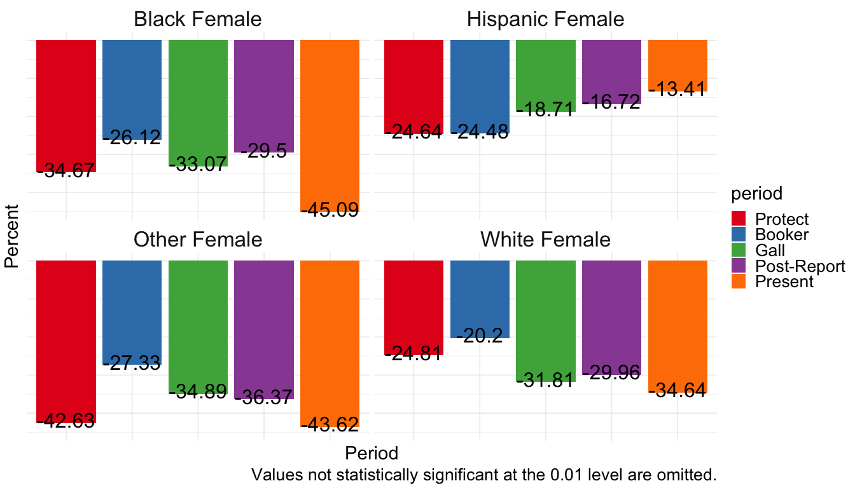
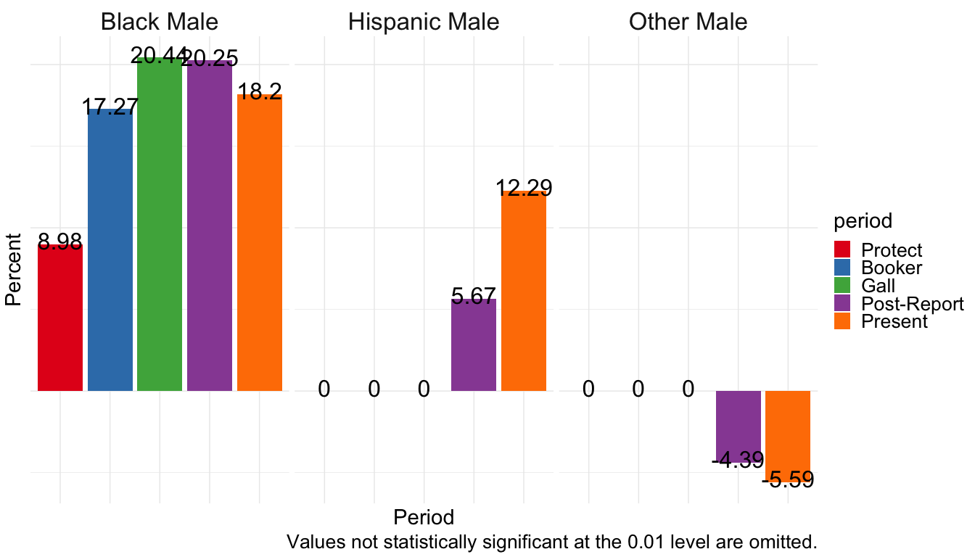

White Female Baseline
Note the colors are scrambled slightly where no statistically significant difference in groups exists during the Protect period.
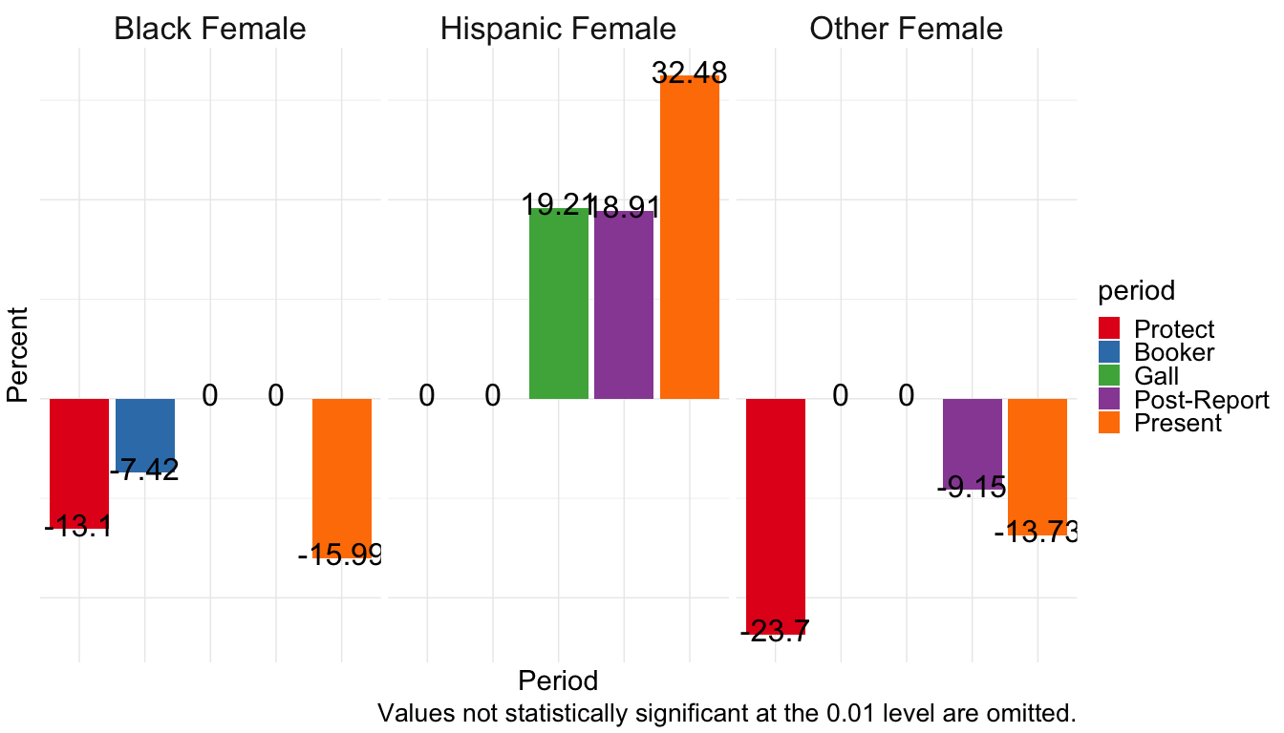
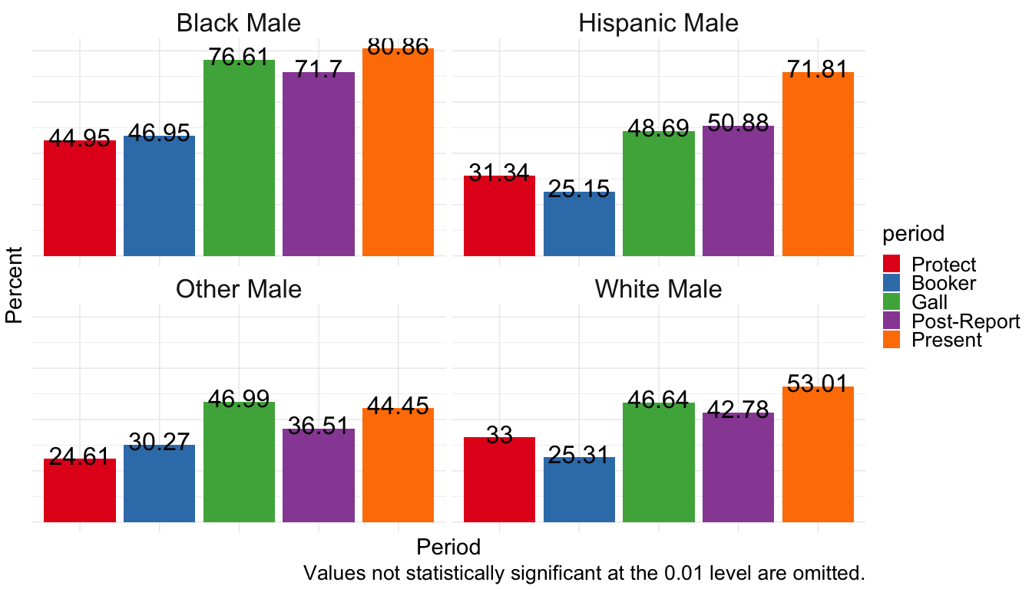

Hispanic Female Baseline
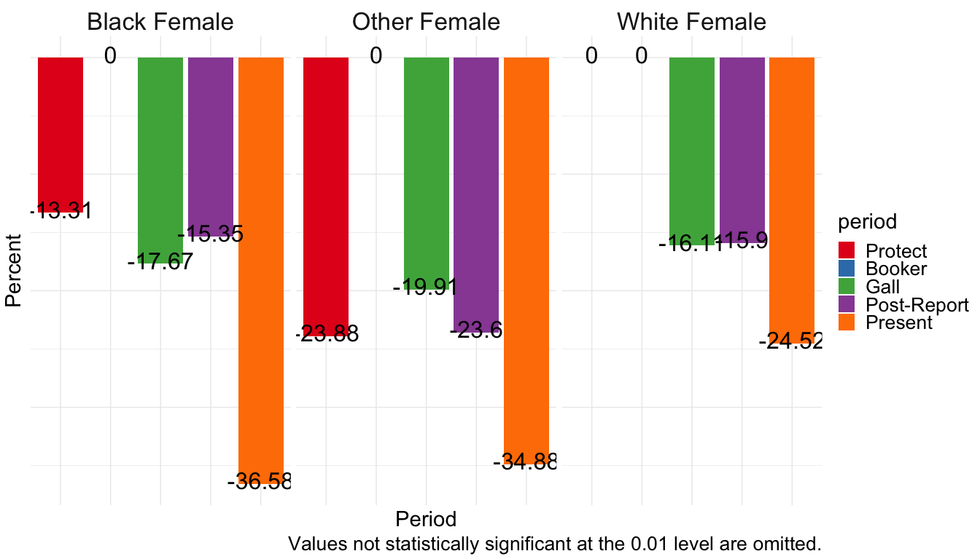
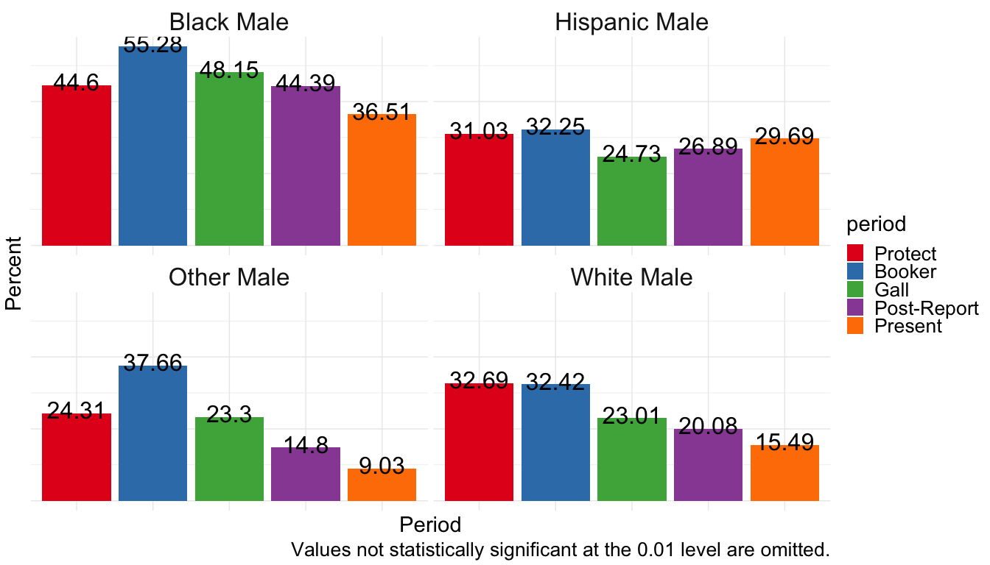

Black Female Baseline
